Gian Biondi Applications 7/3/12

Musical scores are meant to be read.  In the digital age, there are many ways of reading and creating sheet music using technology.  Musical notation stored in a format like MusicXML or ABC Notation is viewable anywhere, be it natively on a computer or through the internet or even on mobile devices.  To properly develop an app, it is important to know what is already available to consumers.  As such, this paper will analyze and discuss musical notation display tools that are already in use and available.

Tools are available across many different platforms.  There are applications designed for use with a computer, web-apps and mobile apps.  This paper will discuss primarily mobile apps designed for Apple Inc.’s iOS platform.  This is because it was difficult to find any applications for Google’s Android operating system that matched the criteria of rendering MusicXML or ABC notation on a screen.

For the iOS platform, specifically for the iPad, there is a multitude of choices of application available. This paper will cover a subset of all the applications found on the internet. I first found a large list of applications compatible with MusicXML on their website. I narrowed this list down by disqualifying any application that did not have a website or detailed documentation. I then further narrowed the list by choosing only applications which focused on displaying symbolic notation.  Some of the applications which met my criteria include TablEdit, Notion, iCompose, and SeeScore.

SeeScore is an application for the iPad which displays musical scores.  It is developed and maintained by Dolphin, a small company located in Cambridge, UK.  SeeScore reads and displays MusicXML dynamically.  It renders the music on the iPad screen, allowing the user to zoom in and out and still be crisp and clean and readable and fits the screen.  This is unlike some other approaches which renders the image upon the first load and keeps it as a static image or a PDF.  SeeScore also has the added feature of a metronome as well as a feature which highlights the current bar being played.  Of all the mobile apps, this one is the closest to what the Recital app is trying to accomplish.  SeeScore does not come cheap; it runs about fifteen dollars on the Apple Inc. iTunes Store.

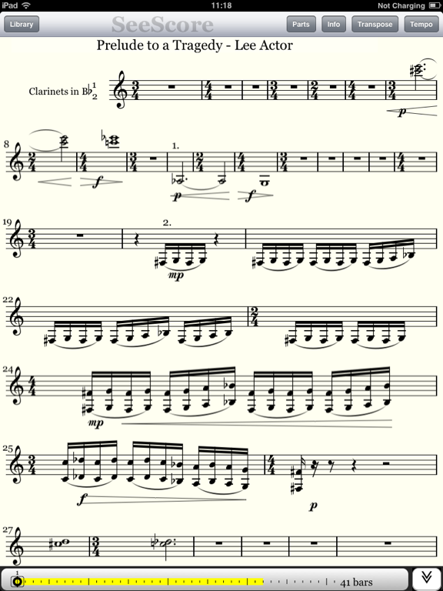

Figure 1 SeeScore for iOS

iComposer is another iOS application for displaying and editing musical scores.  iComposer can import and export sheet music in MusicXML format.  It’s really convenient for transcribing tunes and scores, especially on the move because it was designed to work with either the iPhone or iPad platform.  iComposer can also generate and play audio from symbolic musical scores using over one-hundred and thirty built-in instruments.  While iComposer does seem powerful, there seems to be more of an emphasis on composing rather than just reading sheet music.  iComposer runs about nine dollars in the iTunes store for the full version and also has a free version which is ad-supported and sports limited features.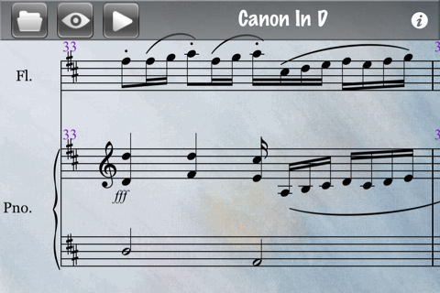

Figure 2 iComposer viewer

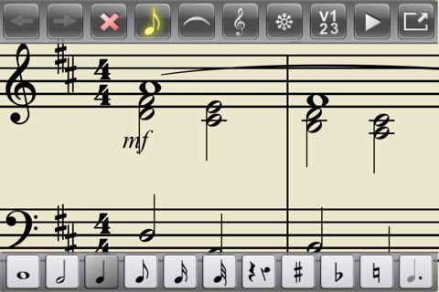

Figure 3 iComposer Editor

Notion is another iOS app which is designed for composing, editing, and playback of scores using real audio samples performed by The London Symphony Orchestra recorded at Abbey Road Studios. The application is designed specifically for the iPad.  Notion has a very user-friendly interface and simple interactive piano keyboard, fret board, and drum pad which makes it natural and easy to compose or edit music.  In addition to the notation editor you can also hear your music performed with real audio samples. NOTION comes bundled with piano and orchestral samples recorded by The London Symphony Orchestra at Abbey Road Studios as well as popular instruments such as guitar, bass, and much more.  It has no free version and runs about fifteen dollars.

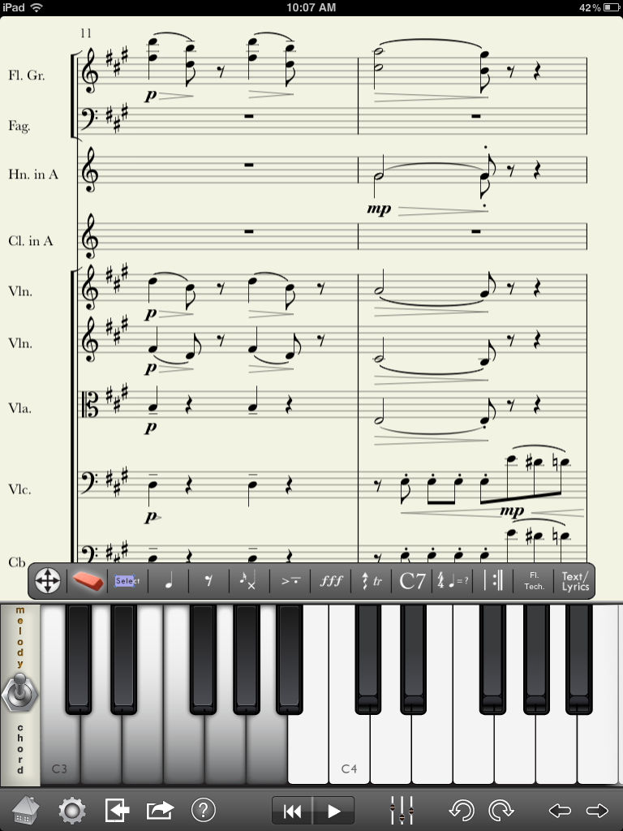

Figure 4 Notion for iOS

The final application is TablEdit.  TablEdit is a Tablature editor for Microsoft Windows and Apple Mac OS.  It is also has a simpler version for iPad known as TEFpad.  Mainly, TablEdit is designed for guitar and fretted instruments but over time it has grown the ability to be used with other instruments such as the drums, the harp, the mountain dulcimer, and many others.  It supports both guitar tablature and standard notation.  TablEdit format or exported to ASCII, HTML, ABC, RTF, MIDI, NIFF, [Lilypond](http://tabledit.com/screen/lilypond.shtml) or WAV formats.  It can even play back tablature in MIDI format.  TablEdit for the Desktop runs about sixty dollars, with the iPad app going for free.  The iPad version offers limited functionality.  For example, TEFpad lacks the ability to create audio.

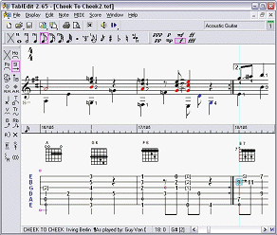

Figure 5 TablEdit for Windows

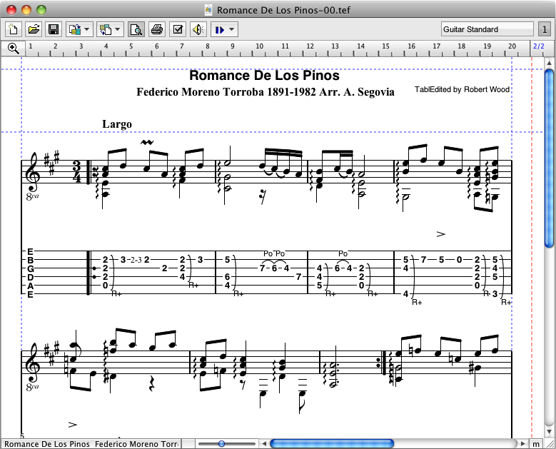

Figure 6 TablEdit for Mac Intel

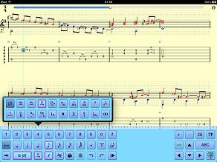

Figure 7 TEFpad for iOS

There are many, many solutions available for displaying digital musical notation across all platforms. Most applications focus on composition and have viewing as an added feature. As such, for mobile iOS applications SeeScore seems to be the closest to what the Recital application should be. SeeScore will be the app we look most closely to when designing and programming our program to read and display musical notation stored in MusicXML format.

|  |  |  |  |
| --- | --- | --- | --- |
| Application | Features | Prices | Platform |
| SeeScore | Dynamic rendering of Music, allows for zooming/scrolling, Metronome and play-along mode | $15USD | iOS: iPad |
| iComposer | Composes music, generates audio from symbolic notation | Free/$9USD | iOS |
| Notion | Composes music, generates audio from symbolic notation, uses audio from London Symphony Orchestra | $15USD | iOS :iPad |
| TablEdit | Composes music, generates audio from symbolic notation, exports notation to many different formats, geared more towards Guitar playing | Desktop: $60USD  iOS: Free | Desktop: PC, Mac  iOS |

Bibliography

MakeMusic. MusicXML. <http://www.makemusic.com/musicxml/community/software>  
TablEdit. TablEdit. [http://tabledit.com](http://tabledit.com/)

Sound Playground. iComposer. <http://v3.soundplayground.com/>  
Notion Music. Notion. <http://www.notionmusic.com/>  
Dolphin. SeeScore. http://www.dolphin-com.co.uk/